Lessons are $40.00 per swimmer, per session.
Lessons are booked first come, first serve with a max. of 10 swimmers (min. 3) per session.
*In person registration on May 13th, from 4-7 pm at the Sumner Family Aquatic Center (1020 Pleasant St).*
**All registration forms must be turned in at City Hall, Public Works Office
or via email (sumnerparkandrec@gmail.com). See deadlines in green below.
***Daily lessons are subject to cancellation at any time due to weather or safety incidents***

Learn 2 Swim Levels | Level Descriptions  Age Recommendations  (Previous Red Cross  Swim Lesson Levels) | Skill Development  (Parent Expectations) | Session Schedule  Session 1: June 2-6 (register by 5/26)  Session 2: June 9-13 (register by 6/2)  Session 3: June 16-20 (register by 6/9)  Session 4: June 23-27 (register by 6/16)
BARNACLES   | Swim Starters  (Water acclimation)  Ages: 6 months-3 years  (Level Parent-Tot) | - Water Discovery  - Water Exploration  (Parent MUST be in water with child) | Session 1: 5-6pm  Session 3: 5-6pm
SHRIMPS 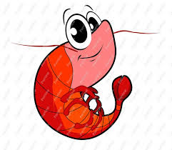 | Swim Starters  (Swim readiness skills)  Ages: 3-5 years  (Level Preschool) | - Water Discovery  - Water Exploration  (For children swimming WITHOUT parental assistance) | Session 1: 9-10am  Session 2: 10-11am  Session 3: 9-10am, 5-6pm  Session 4: 10-11am, 5-6pm
TADPOLES   | Swim Basics  (Beginning of true swim lessons)  Ages: 5+ years  (Level 1) | - Water Exploration  - Water Acclimation  - Water Movement | Session 1: 10-11am, 5-6pm  Session 2: 9-10am, 5-6pm  Session 3: 10-11am  Session 4: 9-10am
GUPPIES  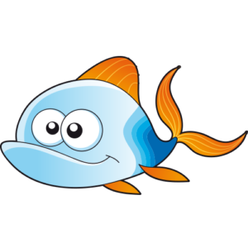 | Continued Swim Basics  Prerequisites: Completed Tadpoles  (Level 2) | - Water Movement  - Water Stamina | Session 1: 9-10am  Session 2: 10-11am, 5-6pm  Session 3: 9-10am  Session 4: 10-11am
SQUID   | Swim Stroke Introduction  Prerequisites: Completed Guppies  (Level 3) | - Water Movement  - Water Stamina | Session 2: 9-10am  Session 3: 10-11am  Session 4: 9-10am, 5-6pm
MARLINS  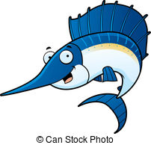 | Swim Stroke Development  Prerequisites: Completed Squids  (Level 4) | - Water Stamina  - Stroke Development | Session 2: 10-11am  Session 3: 9-10am
DOLPHINS   | Swim Stroke Refinement  Prerequisites: Completed Marlins  (Level 5) | - Stroke Refinement  - Healthy Swim Lifestyle | Session 3: 10-11am  Session 4: 9-10am
SHARKS  (Swim Team)  | Swimming Competition  Prerequisites: Completed Dolphins  Ages: 5-18 years  (Level 6)  Contact Taunya Robertson if interested  319-240-7201 | - Stroke Fundamentals  - Competitive Swimming  - Team Environment | Daily Practice:

